



C++ PROGRAMMING
(335)
NATIONAL 2021

APPLICATION KNOWLEDGE:
Check Database Parser and Reporter (400 points)

TOTAL POINTS (400 points)

Test Time: 90 minutes

Check Database Parser and Reporter

While the use of mobile apps and credit or debit cards are more prevalent now, many businesses still use traditional checks as the primary method of payments. For these businesses, it helps to have a database of checks tendered and be able to generate those checks at the end of a payment period. This concept also applies to payroll systems that do not use direct deposit. In this exercise, you will create a C++ console application that reads in a small database of tendered checks and display them in a manner like how a check looks.

For the file provided (checkdata.txt), the first two check displays should be as follows.

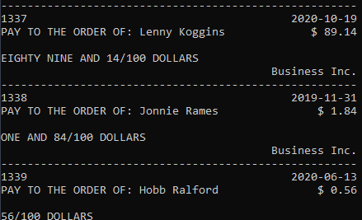
Figure 1: Sample output using provided checkdata.txt input

The provided checkdata.txt is formatted to first specify the starting ID of the first check, with each subsequent line being the name of the person being paid, the date of the check, and then the amount to be paid. The first check line uses the starting ID, and all subsequent checks use an incremented ID (use Figure 1 as an example).

To facilitate the parsing, formatting, and reporting of check data, a Check class should be used. This check type should contain the string data tokens pulled from the data file, the current check ID, suitable constructors, suitable getters and setters, as well as functions to format date from the style provided in the data file to the format shown in Figure 1. Additionally, the Check class should have static functions that parse out the amount into a human readable format, display a check object, and return a check object based on string input by calling a suitable constructor.

When a check object is created, the use of a suitable data structure should be used. For this exercise, construct a generic List class that can have a variable type (that is, can be used to store objects of any type) using templates. The List class must use a pointer array as the underlying storage mechanism and have a suitable constructor as well as deconstructor. To reduce bloated code, overload the indexing operator to accept an integer index and return the element in the pointer array at the target index.

Requirements:

- You must create a C++ console application named CPP_335_ContestantNumber, where ContestantNumber is your BPA assigned contestant number (including dashes). For example, CPP_335_01_2345_6789.
- Your contestant number must appear as a comment at the top of the main source code file.
- A Check class shall be implemented to store the data for a check object stored in the provided data file, as well as provide conversions for date and human readable currency.
  - Check shall have static functions for parsing currency into human readable format, displaying a check object, and calling the suitable constructor to create a check object based on string input.
  - Suitable getters, setters, and constructors shall be created.
- A generic List class shall be implemented using class templates to act as the storage mechanism for the parsed Check object database.
  - List shall use the overloaded index operator to access the underlying storage structure, which is a pointer array.
  - List shall have a proper set of functions, including constructor and deconstructor.
- When application starts, application shall load all checks stored in provided file into a generic List of Check objects (can hardcode file path or request user input for path).
  - If the file was not able to be opened, application shall show an error message indicating that there was an error.
- Check ID shall be loaded as the first line in the provided data file, with any check after the first having an incremented ID from that starting point.
- Report format shall match that shown in Figure 1.
- When finished reporting, the application shall pause and wait for the user to press a key to exit the application.

Your application will be graded on the following criteria:

Solution and Project

The project is present on the flash drive ____ 10 pts
The project is named according to the naming conventions ____ 10 pts

Program Execution

Code copied to USB drive and the program runs from USB ____ 10 pts

If the program does not execute, then the remaining items in this section receive a score of zero.

Application displays error message if cannot load file ____ 15 pts
Application successfully loads list of checks ____ 15 pts
Application displays each check item stored in file ____ 25 pts
Application displays each check items in specified layout ____ 30 pts
Check amount is displayed in a human readable format ____ 40 pts
Date information is converted and displayed in specified format ____ 30 pts
Check ID is properly loaded and incremented for subsequent checks ____ 20 pts
Application pauses once execution is complete ____ 20 pts

Source Code Review

Code is commented at the top, for each function, and as needed ____ 15 pts
Code uses reasonable and consistent variable naming conventions ____ 15 pts
Application report is not hardcoded ____ 10 pts
Check class is implemented according to specification ____ 25 pts
Generic List class is implemented according to specification ____ 30 pts
List class properly uses overloaded indexing operator ____ 30 pts
File error handling is performed properly ____ 30 pts
Application is properly modular in design ____ 20 pts

Total Points: 400 pts

Expected Output from Key Input
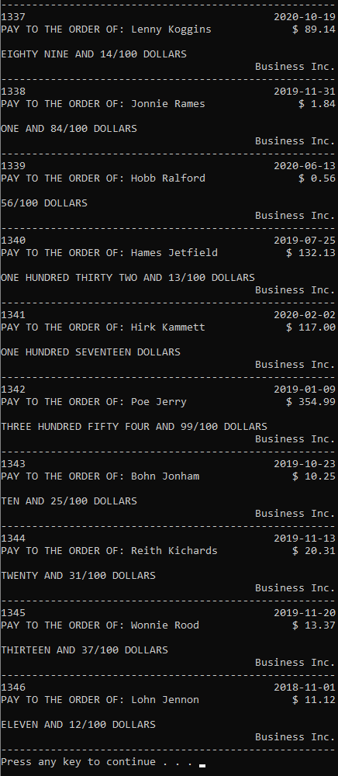
Completed Source Code
Main.cpp
#include <iostream>
#include <fstream>
#include "Check.h"
#include "Library.h"
#include "List.h"

using namespace std;

const string filePath = "checkdata.txt";

// Populates the check list and retrieves the initial checkID
bool PopulateList(int& checkID, List<Check>& checkList);

// Formats and sets the ID of every element of the checklist
void FormatList(int checkID, List<Check>& checkList);

int main()
{
int checkID; // The initial ID
List<Check> checkList(20); // A list of each check
if (PopulateList(checkID, checkList))
{
FormatList(checkID, checkList);

cout << string(54, '-') << endl; // Displays header

for (int i = 0; i < checkList.GetCount(); i++)
{
Check::Display(checkList[i]);
}
}
else
{
cout << "File was not able to be loaded." << endl;
}

system("pause");
return 0;
}

// Formats and sets the ID of every element of the checklist
void FormatList(int checkID, List<Check>& checkList)
{
for (int i = 0; i < checkList.elementCount; i++)
{
// Formats, then sets ID while incrementing ID for next check
checkList[i].formatDate();
checkList[i].setID(checkID++);
}
}

// Populates the check list and retrieves the initial checkID
bool PopulateList(int& checkID, List<Check>& checkList)
{
bool success = true;

ifstream dataFile(filePath); // Creates ifstream object
if (dataFile.is_open()) // Ensures file is open
{
// Retrieves ID, then populates checklist from file
string ID;
string line;
getline(dataFile, ID);
checkID = atoi(ID.c_str());

while (getline(dataFile, line))
{
checkList.Insert(Check::GetCheck(line));
}
}
else
{
success = false;
}

return success;
}

List.h
#ifndef List_h
#define List_h

#include <iostream>
#include <fstream> // Allows file IO
#include <string> // Allows use of string
#include <vector> // Allows use of vectors
#include <iomanip> // Allows manipulation of output
#include <sstream> // Allows for easy string parsing
#include "Library.h" // Allows access to general methods

using namespace std;

template <class T>
class List
{
private:
T* array; // The container of type T
public:
int elementCount; // Stores number of elements
int maxSize; // Stores current capacity of list

// Allows the object to be indexed
T& operator[] (int x) { return array[x]; }

// Default constructor, with size set to 10
// if no value is passed with it
List(int newSize = 10)
{
Initialize(newSize);
}

// Initializes list as an empty
// array with newSize elements
void Initialize(int newSize)
{
array = new T[newSize];
maxSize = newSize;
elementCount = 0;
}

// Returns number of elements
int GetCount()
{
return elementCount;
}

// Frees up dynamically allocated memory
~List()
{
delete[] array;
}

// Inserts a new item
void Insert(T newItem)
{
// Inserts new value at end
array[elementCount] = newItem;
elementCount++;
}
};

#endif
Check.h
#ifndef Check_h
#define Check_h

#include <iostream>
#include <string>

using namespace std;

class Check
{
private:
string name; // Holds the recipient of the check
string date; // The date of the check
string amount; // The amount the check is worth
int id; // The check's ID
public:
Check(string data); // Constructs using data string
Check(); // Default constructor with junk values

// Formats a given date from month/day/year
// to year-month-day
void formatDate();

// Mutator method for ID
void setID(int newID);

// Converts the check amount from a dollar
// value to english text
static string AmountToEnglish(Check check);

// Displays a check
static void Display(Check check);

// Retrieves a check from a data string
static Check GetCheck(string data);
};

#endif
Check.cpp
#include <iostream>
#include <vector>
#include <string>
#include <iomanip>
#include "Check.h"
#include "Library.h"

using namespace std;

// Constructs using data string
Check::Check(string data)
{
vector<string> checkTokens = Split(' ', data);
name = checkTokens[0];
name.append(" " + checkTokens[1]);
date = checkTokens[2];
amount = checkTokens[3];
}

// Default constructor with junk values
Check::Check()
{
amount = "500";
date = "1/2/03";
id = 1;
name = "John Doe";
}

// Formats a given date from month/day/year
// to year-month-day
void Check::formatDate()
{
vector<string> dateTokens = Split('/', this->date);
this->date = "20";
this->date.append(dateTokens[2] + "-");
if (atoi(dateTokens[0].c_str()) < 10)
this->date.append("0");
this->date.append(dateTokens[0] + "-");
if (atoi(dateTokens[1].c_str()) < 10)
this->date.append("0");
this->date.append(dateTokens[1]);
}

// Converts the check amount from a dollar
// value to english text
string Check::AmountToEnglish(Check check)
{
vector<string> currencyTokens = Split('.', check.amount);
int dollars = atoi(currencyTokens[0].c_str());
int cents = atoi(currencyTokens[1].c_str());
return DollarsToEnglish(dollars, cents);
}

// Mutator method for ID
void Check::setID(int newID)
{
id = newID;
}

// Displays a check
void Check::Display(Check check)
{
cout << check.id << setw(50) << check.date << endl;
cout << "PAY TO THE ORDER OF: " << setw(20) << left << check.name;
cout << right << setw(13) << "$ " + check.amount << endl << endl;
cout << AmountToEnglish(check) << endl;
cout << setw(54) << "Business Inc." << endl;
cout << string(54, '-') << endl;
}

// Retrieves a check from a data string
Check Check::GetCheck(string data)
{
return Check(data);
}
Library.h
#ifndef Library_h
#define Library_h

#include <iostream>
#include <fstream> // Allows reading of files
#include <string> // Allows use of getline(ifstream, string)
#include <iomanip> // Allows output manipulation
#include <sstream> // Allows splitting of string
#include <vector> // Allows use of vectors

using namespace std;

// Splits a selected string into a collection
// of strings separated by a given delimeter
vector<string> Split(char delim, string input);

// If answer is not blank, pad the string
string PadNumber(string answer);

// Converts a hundred value to text
string translateHundred(int amount);

// Converts a thousand value to text
string translateThousand(int amount);

// Converts a given dollar and cents amount to English text
string DollarsToEnglish(int dollars, int cents);

#endif
Library.cpp
#include <iostream>
#include <fstream> // Allows reading of files
#include <string> // Allows use of getline(ifstream, string)
#include <iomanip> // Allows output manipulation
#include <sstream> // Allows splitting of string
#include <vector> // Allows use of vectors
#include "Library.h"

using namespace std;

// Splits a selected string into a collection
// of strings separated by a given delimeter
vector<string> Split(char delim, string input)
{
vector<string> tokens; // Collection of string tokens
stringstream stream(input); // Stringstream of input
string token; // Used to pull out individual tokens
// While delims still present in string...
while (getline(stream, token, delim))
if (token.compare(""))
tokens.push_back(token); // Add to vector
return tokens; // Returns collection
}

string Powers[] = { "", "THOUSAND", "MILLION", "BILLION" };
string Ones[] = { "", "ONE", "TWO", "THREE", "FOUR", "FIVE",
"SIX", "SEVEN", "EIGHT", "NINE", "TEN", "ELEVEN",
"TWELVE", "THIRTEEN", "FOURTEEN", "FIFTEEN", "SIXTEEN",
"SEVENTEEN", "EIGHTEEN", "NINETEEN" };
string Tens[] = { "", "", "TWENTY", "THIRTY", "FORTY", "FIFTY",
"SIXTY", "SEVENTY", "EIGHTY", "NINETY" };

// If answer is not blank, pad the string
string PadNumber(string answer)
{
if (answer == "")
return "";
return " " + answer;
}

// Converts a hundred value to text
string translateHundred(int amount)
{
// If less than 20, simply return the value from Ones array
if (amount < 20)
return Ones[amount];
// Get the number of tens and ones, then pad the ones and append
int tens = amount / 10;
int ones = amount % 10;
return Tens[tens] + PadNumber(Ones[ones]);
}

// Converts a thousand value to text
string translateThousand(int amount)
{
// If less than 100, translate it in that respect
if (amount < 100)
return translateHundred(amount);
// Get the amount of hundreds and tens
// Then append the hundreds and pad the result of hundred translation
int hundreds = amount / 100;
int tens = amount % 100;
return Ones[hundreds] + " HUNDRED" + PadNumber(translateHundred(tens));
}

// Converts a given dollar and cents amount to English text
string DollarsToEnglish(int dollars, int cents)
{
string result = ""; // The value in English
int number = dollars; // Gives a changeable value for dollars
int power = 0; // Determines power
while (number > 0)
{
if (number % 1000 != 0) // If there is value in thousands
{
// Translate the thousands value and add necessary power
result = translateThousand(number % 1000) +
PadNumber(Powers[power] + PadNumber(result));
}
number /= 1000; // Adjust by power
power++; // Increment power
}

if (cents != 0) // If there are cents
{
if (dollars != 0) // If there are no dollars
result.append(" AND ");
// Add the cents as a string
result.append(to_string(cents) + "/100");
}
result.append(" DOLLARS");
return result;
}

